**This is also the weekend of the Annual New Bern Mumfest! Come to Downtown New Bern and enjoy the fun.**

**Visit the SEAFAIR – a 228 ft. mega yacht with 3 decks of 28 galleries filled with art, jewelry and sculpture from national and international artists.**

**There are 12 rooms reserved at the Comfort Suites in New Bern for a limited time only. Please call 252-636-0022 to make your reservation ASAP.**

If you sign up for both dinners, it will be $20 per person.

All Property Owners, their guests and anyone playing in our Member Guest Tournament will be allowed to participate in these events.

RSVP for both dinners by Monday, October 8th at 10 am to Ken Gerhardt at 772-0201 or kgerhardt@carolinacolours.com

## October 12th and 13th

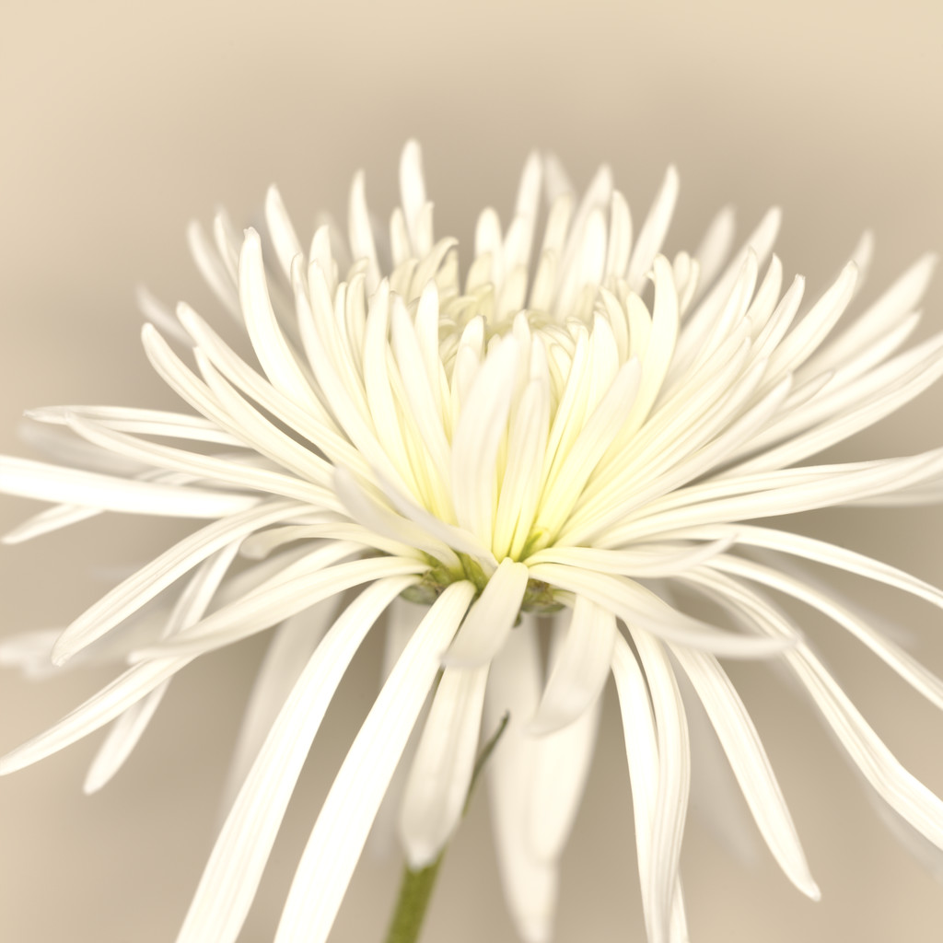

# Annual Carolina Colours Property Owners Weekend

Friday Night October 12, 2012

Members Dinner at the Pavilion

Smithfield’s BBQ - $10 Per Person

Pulled BBQ ~ Hush Puppies ~ Fried Chicken ~

Baked Beans ~ Cole Slaw ~ Rolls

Cocktails start at 5 pm with dinner at 6:30

There will be a DJ from CK Entertainment from 7 pm – 10 pm

Saturday Night October 13, 2012

Member – Guest Dinner at the Pavilion

Prepared by Chef Katherine - $15 Per Person

Maple Mustard Pork Roast ~ Vermouth Steamed Mussels

And Shrimp ~ Three Potato Gratin ~ Chef’s Choice

Vegetable ~ Mixed Green Salad ~ Bread/Rolls ~

Apple Crisp

Cocktails start at 5 pm and dinner served at 6:30 pm